Jasmine Testing

PLEASE NOTE!! I accidentally put the script tag for jasmine testing twice for the “Home Page Testing”. This is why there is two outputs for the same text.

# Home Page Testing

For the home page I tested the changing speed of the background images. The jasmine script I wrote of this, is the following.

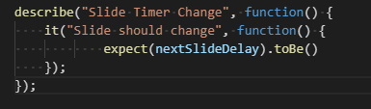

“nextSlideDelay” is the variable I set for the changing slide timer. It should equal 5000 as it is set to change every 5 seconds.

## Failing Test

### Failure 1

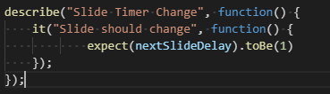

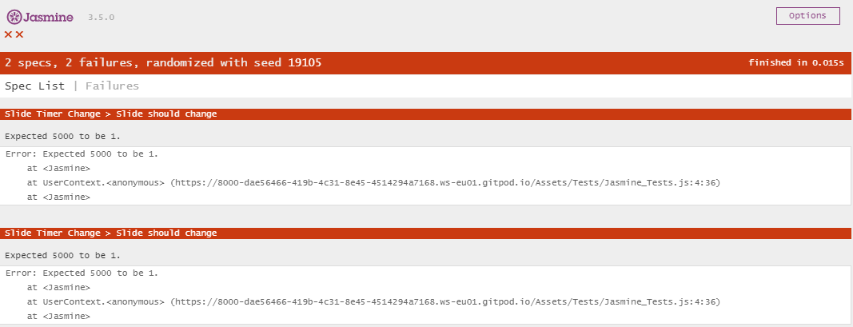

### Failure 2

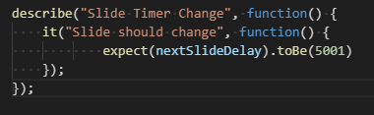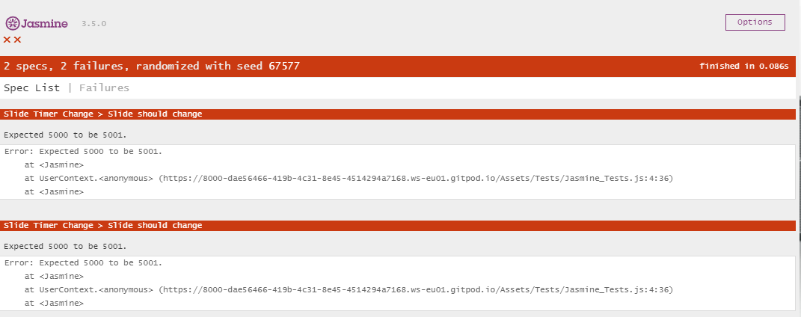

### Failure 3

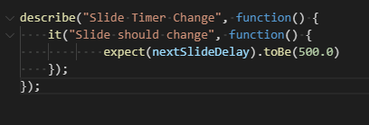

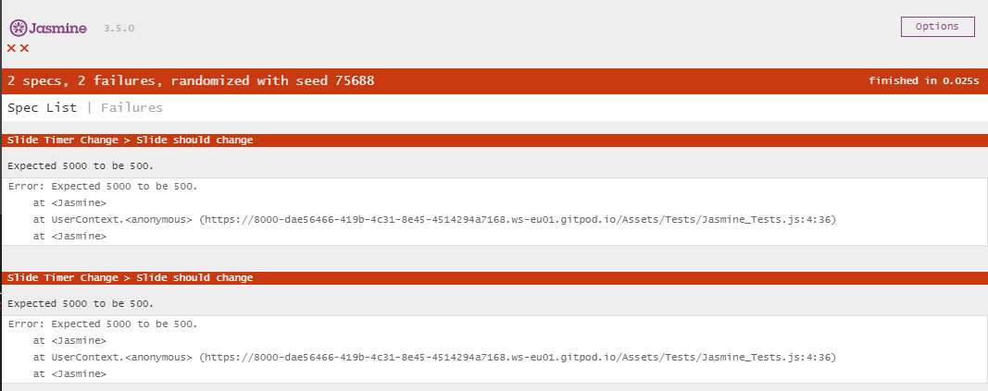

As you can see these all failed as the variable doesn’t equal any of these numbers. I tried a close number and numbers that have the same amount of digits but include various symbols to see if it would pass but it didn’t.

## Passing Test

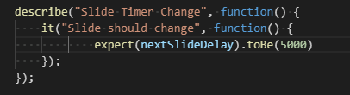

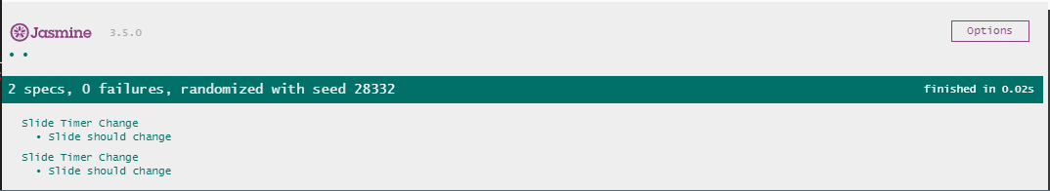

This one passed has this is the correct number of the variable implemented into the Javascript. I want the slide to change every 5 minutes so this is what it does.

# Band Page Testing

On this page I tested the scroll feature. The first test is the variable that it should take you too which is the top of the page.

So the way it’s expected to go is once clicked it takes you to the top of the website. The variable I used to do this was called “document.body.scrollTop” and “document.documentElement.scrollTop”.

They should both be set to 0 so once it’s clicked the variable will take you to the top of the page positioned 0 at top.

The jasmine script I used was the following.

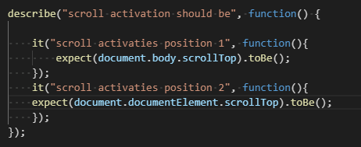

## Failing Test

### Failure 1

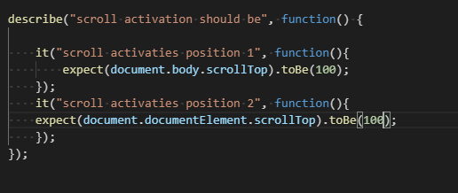

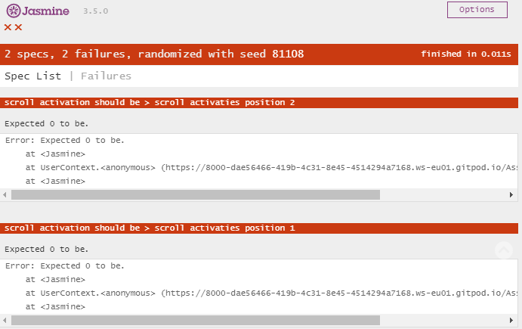

As it is not with a number that is not zero it fails. Hence why the 100s both failed.

### Partial Failure

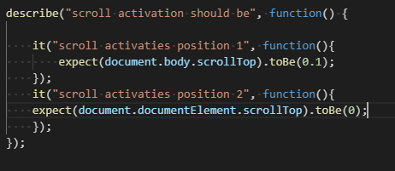

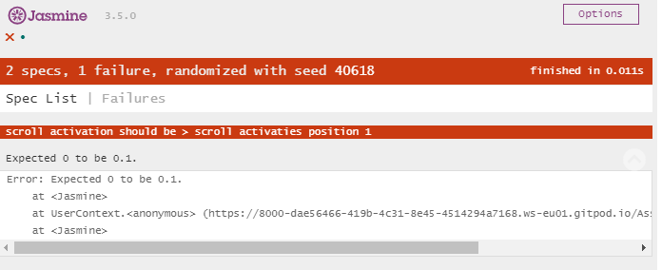

In this test on passed one failed but the one that failed was very close to the actual the actual number but because it wasn’t exact it failed.

## Passing Test

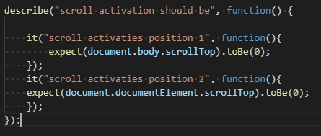

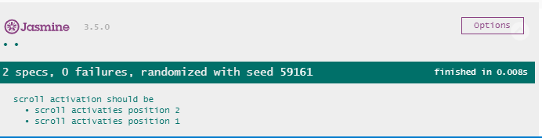

Since it was looking for both variables to be 0 it worked as that is how they are set and expected to work in this feature.